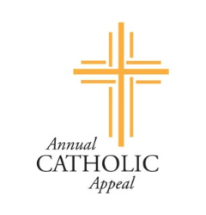
What is the difference between the
Annual Catholic Appeal and Parish Stewardship?

ANNUAL CATHOLIC APPEAL

- Occurs in the spring of each year
- Catholics and Parishes across Western Washington support the Archdiocesan campaign
- Pledge to the Archdiocese-May to April
- Donations processed through the Archdiocese
- Monthly reminders are sent from the Archdiocese
- Tax statement provided by the Archdiocese
- Supports over 60 ministries and services throughout Western Washington including:
  - Catholic Community Services
  - Catholic Schools Department
  - College Campus Ministry Services
  - Catholic Youth Organization (CYO)
  - Seminarian & Deacon Candidate Services
  - Priests’ Retirement
PARISH STEWARDSHIP OF TREASURE
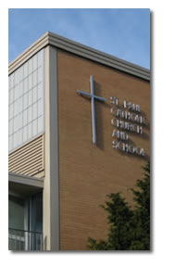
- Occurs in the fall of each year
- St. Paul Parishioners support the Parish campaign
- Yearly pledge to the parish- January to December
- Donations processed through the parish
- Parish office sends bi-monthly envelopes and periodic reminders
- Tax statement provided by the parish
- Provides parish ordinary income supporting the work and ministries of St. Paul Parish including:
  - Parish Ministries
  - Sacramental Preparation
  - Church and Building Maintenance
  - St. Paul School
  - Parish and Regional staff and priests

Gifts to the Annual Catholic Appeal and St. Paul Church may be tax-deductible. If your employer offers a corporate matching program, please contact the parish office.

